**WEB DESIGN**

**PROJECT REPORT**

|  |  |
| --- | --- |
| **PROJECT TEAM** | |
| **Student No.** | **Student Names** |
| **16135270** | **Vinit Date** |
| **16136799** | **Carl Mohn** |
|  | **Rajeeva Revankar** |

**Lolcakes**

**http://vcr-ncirl-webproj.netlify.com/**

**Section 1: Design**

1. PROJECT PROPOSAL

## Project Overview

Lolcakes is the company name with a website for marketing custom-made cakes for special occasions. The scale of the business is small, comparable to a part-time job, with limited production facilities.

The goal is to produce a website that would facilitate selling of products and create Internet, including social media, exposure to the business. This exposure is gained by displaying products, sharing ideas with site visitors, and providing an ordering platform.

The website content will be text, images and video clips. For this project – for educational purposes – ‘clipart’ and stock photos are used,

In addition some of the content may be shared on other social media sites, but leaving the website as the main marketing platform.

## Research / Investigation

From a multitude of private-owned companies selling cakes on the Internet, we have picked three examples:

The target group is mainly adults of all ages, who would rather conserve time or who are less proficient in baking and decorating.

The presentation styles are quite different, the first site is intuitive – navigation is made easy by having a semi-static layout, with changing centre content. The third site is even more static, leaving a ‘webpages of the noughties’ look.

The second web site is more advanced technically, with a static banner or menu bar, leaving more room for changeable content in the centre of the pages. The front page seems confusing initially, but is clearly more suited for different platforms by being responsive.

The Cake Shop - http://www.thecakeshop.ie

Pros: Simplicity, easy-to-read fonts, easy to navigate, contrasting colour scheme, image thumbnail utilisation for loading speed

Cons: Not responsive, suboptimal page utilisation, image thumbnails creates an extra step for viewing detail images.

Deborah’s Cakes - http://www.deborahscakes.ie/

Pros: Large images up front, responsive website, pleasant hover-over utilisation on small images

Cons: Obscuring hover-over effects on large images, not as intuitive navigation as the other sites, lacking lucidity

Scrummy Mummy - http://www.scrummymummy.ie

Pros: Simple and clear layout, good image quality, offering courses/workshops

Cons: Only slightly responsive site, suboptimal page utilisation (top half), “outdated look” and possibly not updated since 2016 (year mentioned!)

To make our website stand out is to give the site an overall “fresh” look, with simple navigation, sharp images with details, as the products are visually stimulating. Time and resources allowing video clips will be added as an eye catcher.

The marketing of cakes seem passive – some as passive as a statement such as: “Here are cakes. We sell them.” This is the image we are getting from some of the competitors’ sites. To be more professional about marketing we need to consider some elementary marketing theory such as Marketing Mix (Kotler’s 4 P’s; Product, Price, Place, and Promotion), and how to create demand. Methods for this are very similar to those used by successful companies: Sharing ideas and experiences, sharing “pro tips”, letting people interact via a community or utilise social media, using a mix of visual aids (images; video and still-), to summarise “Get people talking and desiring.”

## Requirements & Technical Approach

The minimum requirements are the following:

* The site should have a minimum of 5 HTML pages
  + The home page should be called index.html
  + One HTML page should include a HTML form
* Site styling controlled by at least one external CSS file
* Clearly defined, consistent, navigation system
* Website must be responsive
* Use of JavaScript (minimum 4 examples)
* Website Deployment

The technical approach:

1. Step by step application of Knowledge gained through lectures and flip reading.
2. Idea collaboration via a WhatsApp group
3. Implementation utilising tools like Git, Eclipse and Netlify
4. Validation through Eclipse initially, then likes of W3schools

## WIREFRAME / SITEMAP

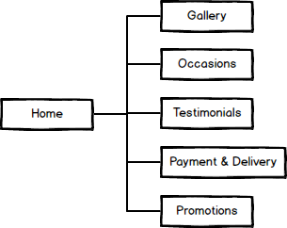

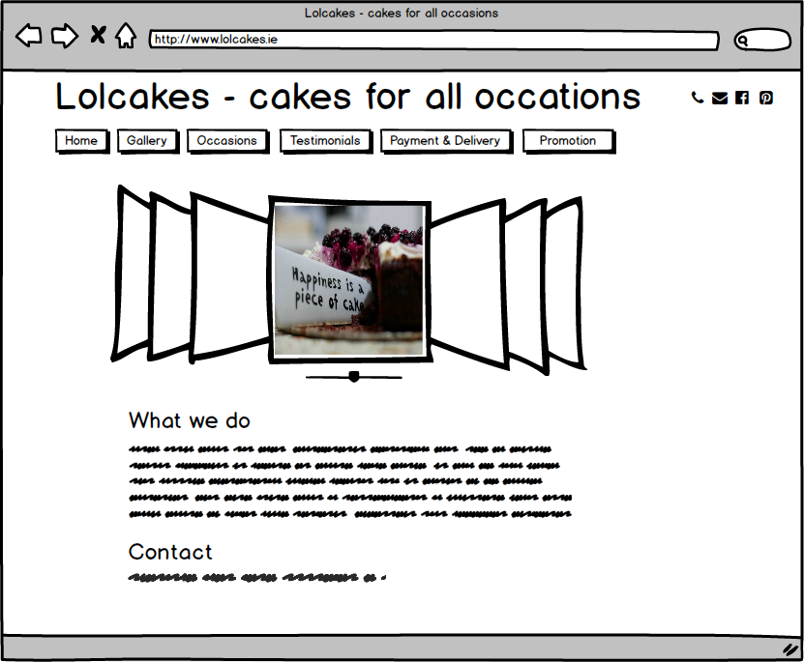

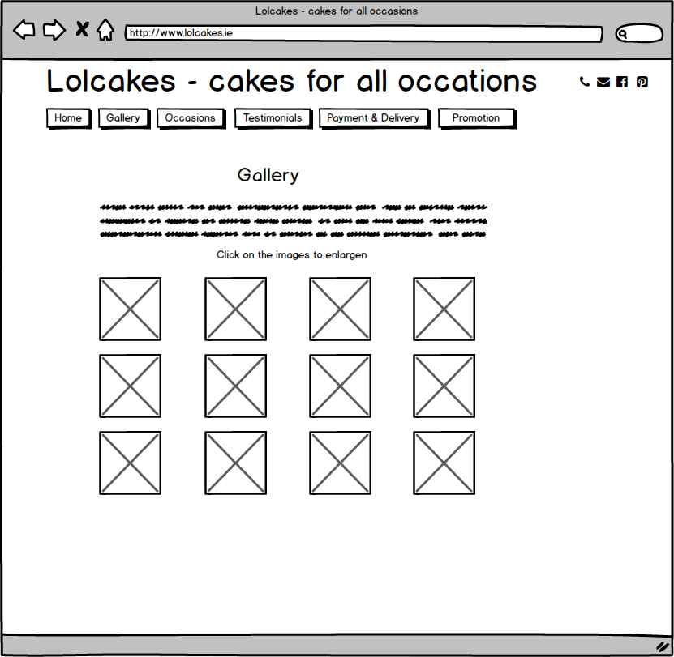

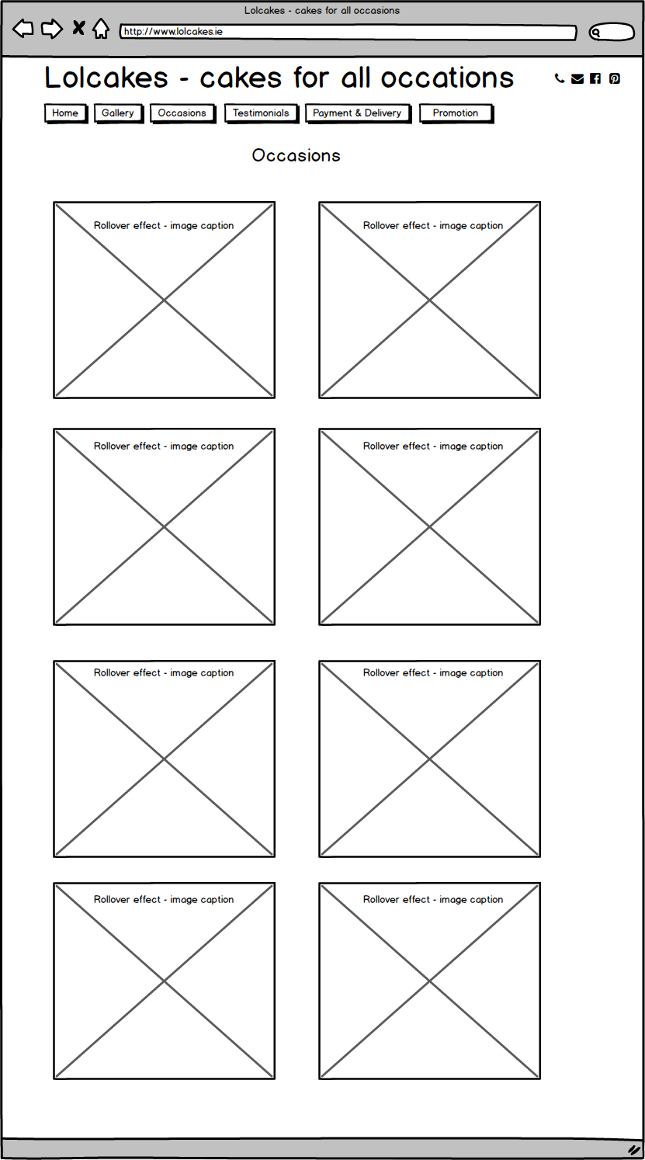

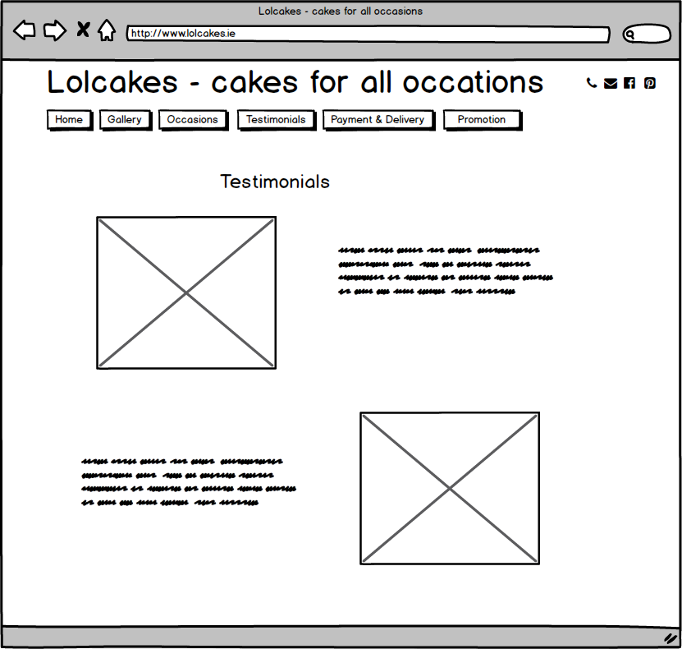

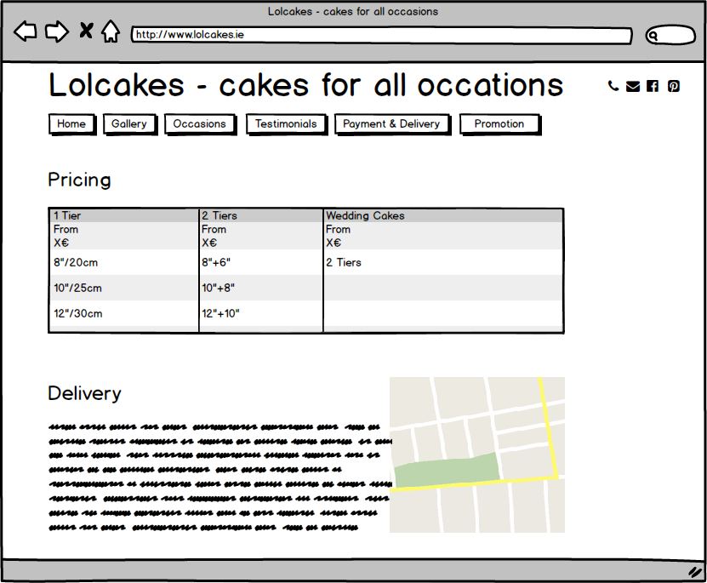

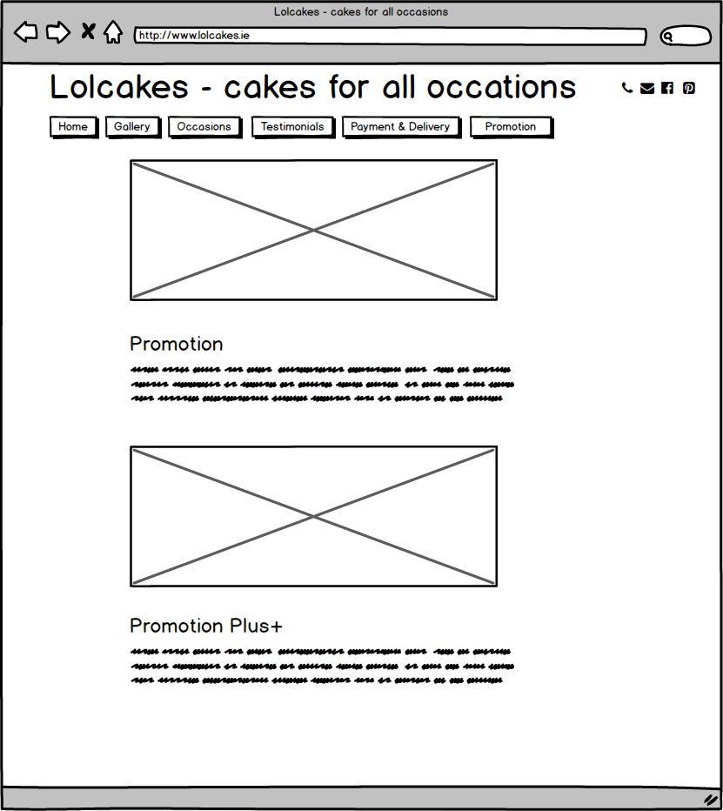

**\*\*\*\*\*\* The following sections should NOT be completed until you have FINISHED your website \*\*\*\*\*\***

**Section 2: Development**

1. **PRODUCTION LOG**

** This section should outline how you went about developing your webpage, i.e. HTML, CSS, JavaScript. This should include information on requirements implementation, code development and technical details, such as errors or development issues and how you fixed these.

**Please note:** Make sure to include explanation (**as well as** comments in the HTML files) of any & all code that was taken from the web, or you will **not** receive marks for this third party code. **

**Validation**

Using Eclipse as the development tool, initial validation was built-in. The final validation of the website HTML and CSS was done using the provided tools:

<https://validator.w3.org/> and <http://jigsaw.w3.org/css-validator/>. Every HTML page was checked with the HTML validator and they passed.

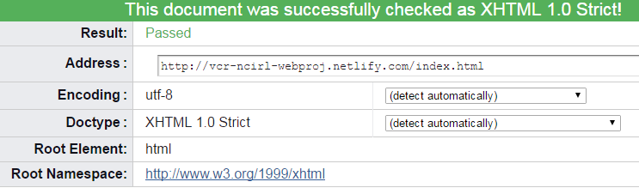

**Deployment**

** This section should include information on your choice of deployment, as well as the sites URL and a screenshot of the live site **

1. **PROJECT TEAM**

Based on the team members’ backgrounds, it was natural for the team to assume the roles of 1) system support and javascript engineering, 2) artistic design and coding and 3) quality assurance, validation and project coordination, while all roles were overlapping, bouncing ideas off each other was a natural working form. The team was communicating via a group chat in WhatsApp and email for the latest ideas, updates and notices. The team had brainstorming sessions, each member contributed equally with different ideas that were reviewed and decisions were made based on the project scope and requirements and through common agreement.

1. **CONCLUSION**

** Having finished the project, looking back, how did the project go?

Did you achieve what you set out to do?

Are you happy with the results?

Is there anything you might change if you had more time? Etc. **\*\***

1. **REFERENCES & APPENDIX**

Thumbnail viewer: <http://highslide.com>, 22/04/2017

Image carousel: <http://www.electricprism.com/aeron/slideshow>, 22/04/2017

Example Images used for educational purposes only:

Bride throwing the groom out cake: <http://snappypixels.com/wp-content/uploads/2013/10/funny-cakes-celebrating-divorce-21.jpg>, 22/04/2017

Rose and Ivy Leaves Wedding cake: <http://www.alloccasionalcakes.co.uk/page_1996109.html>, 22/04/2017

Ham looking cake: <https://www.flickr.com/photos/55881531@N00/307889179>, 22/04/2017

Happiness is a piece of cake: <https://i2.wp.com/cathman.at/wp-content/uploads/2017/02/pexels-photo-227432.jpg>, 22/04/2017

Cthulhu cake (via Pinterest): <https://s-media-cache-ak0.pinimg.com/originals/f6/c5/0c/f6c50c6c137eb8d09238b700cc5de250.jpg>, 22/04/2017

Pizza box cake (via Pinterest): <https://s-media-cache-ak0.pinimg.com/originals/f2/17/ee/f217eed99f76bb0f670ea99c3493eaf8.jpg>, 22/04/2017

Happy Easter cake: <https://www.softlips.net/wp-content/uploads/2017/01/001779.jpg>, 22/04/2017